CS 255 System Design Document - Renee Holliday

UML Diagrams

UML Use Case Diagram
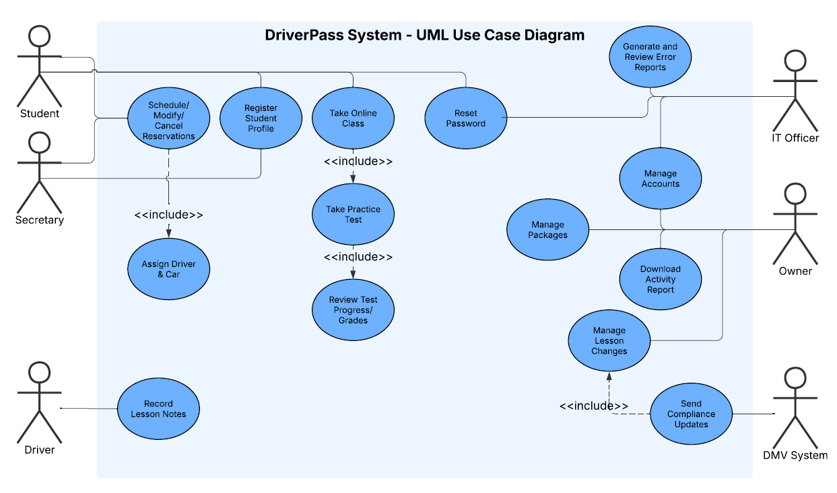

UML Activity Diagrams

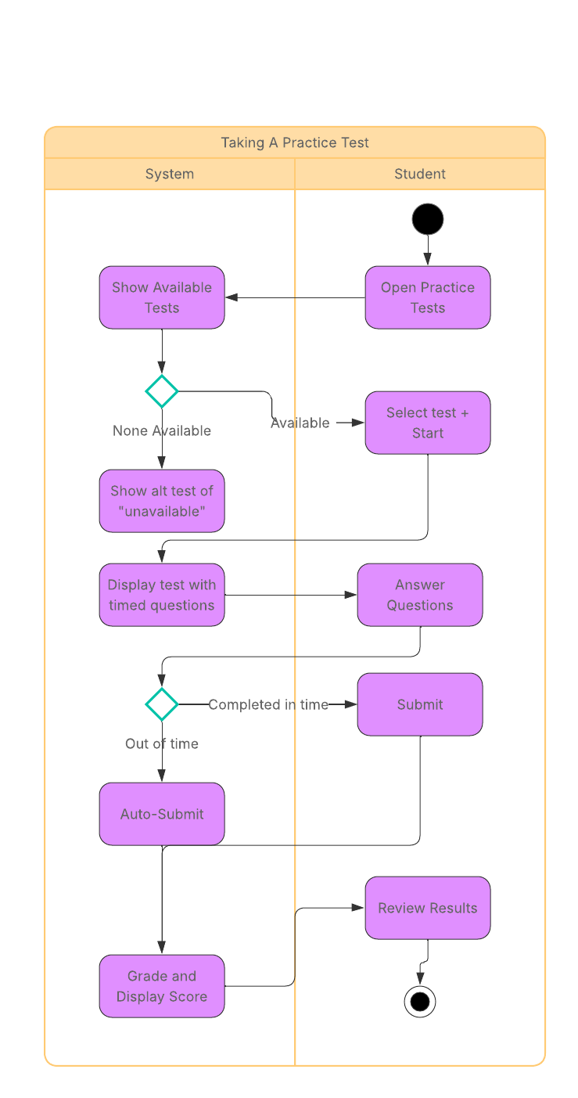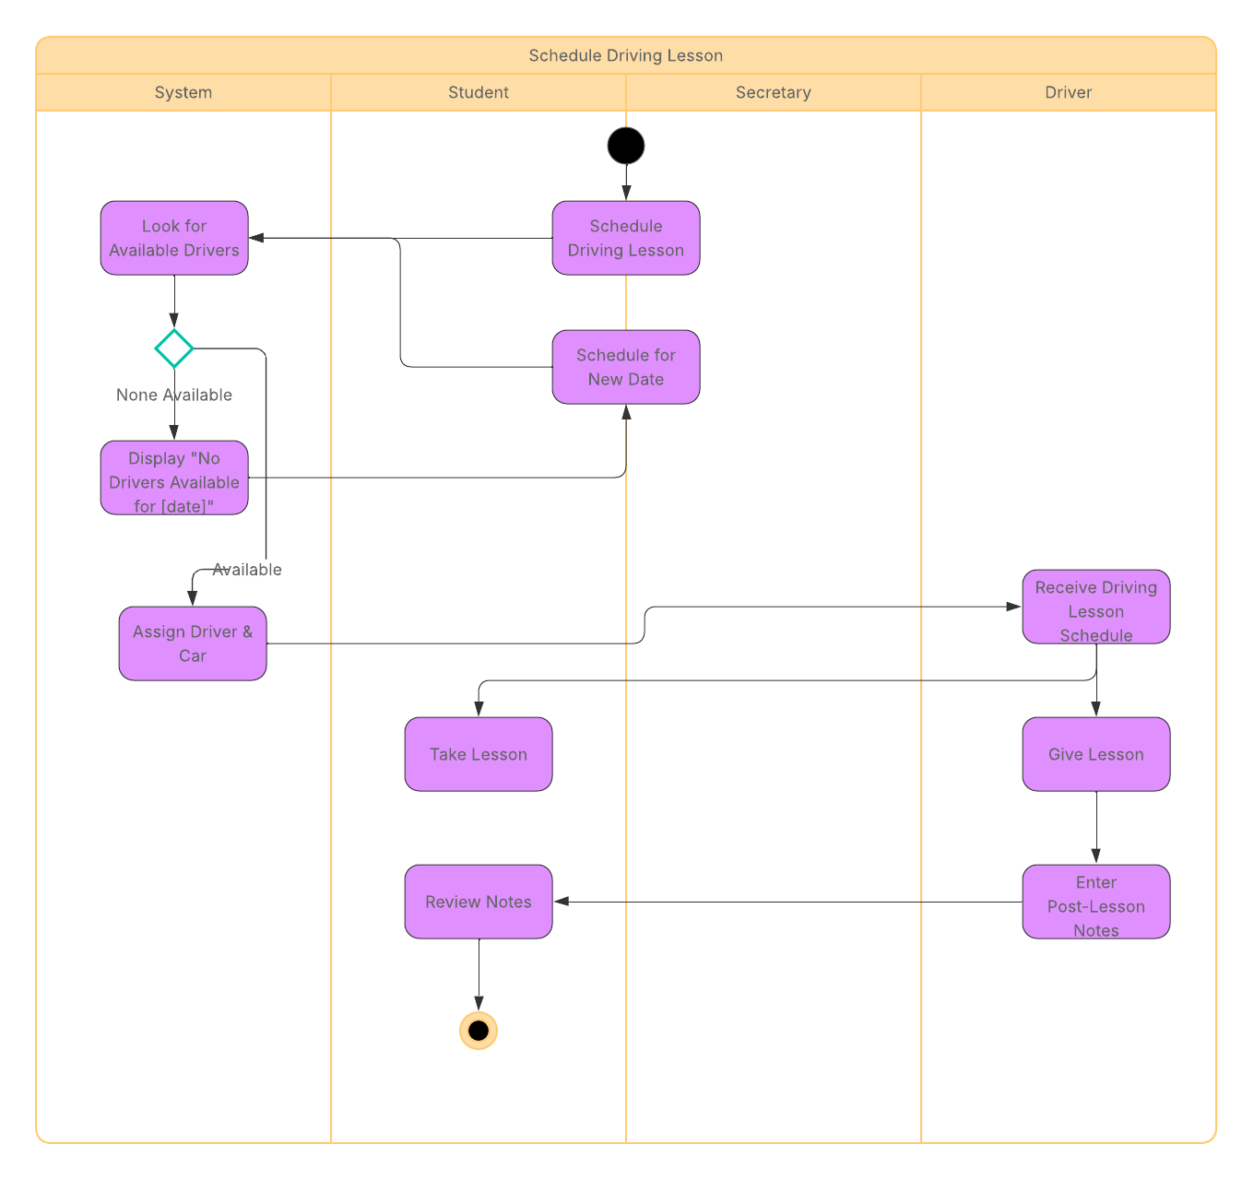

UML Sequence Diagram
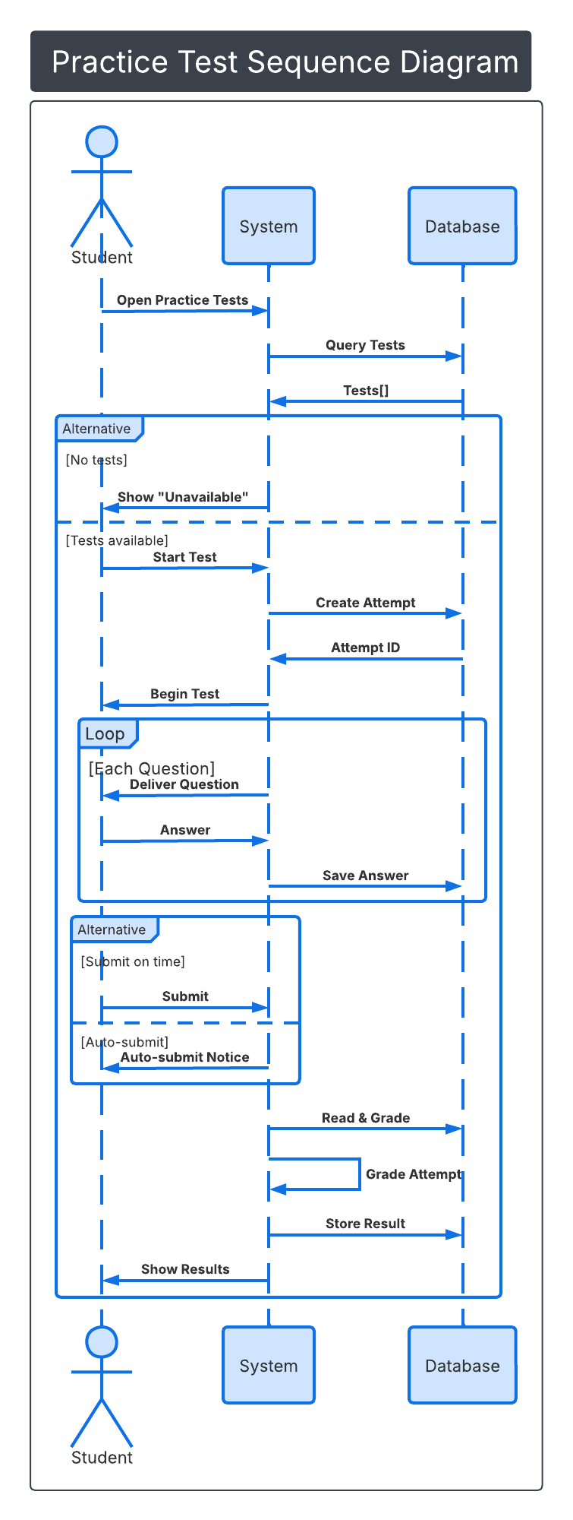

UML Class Diagram

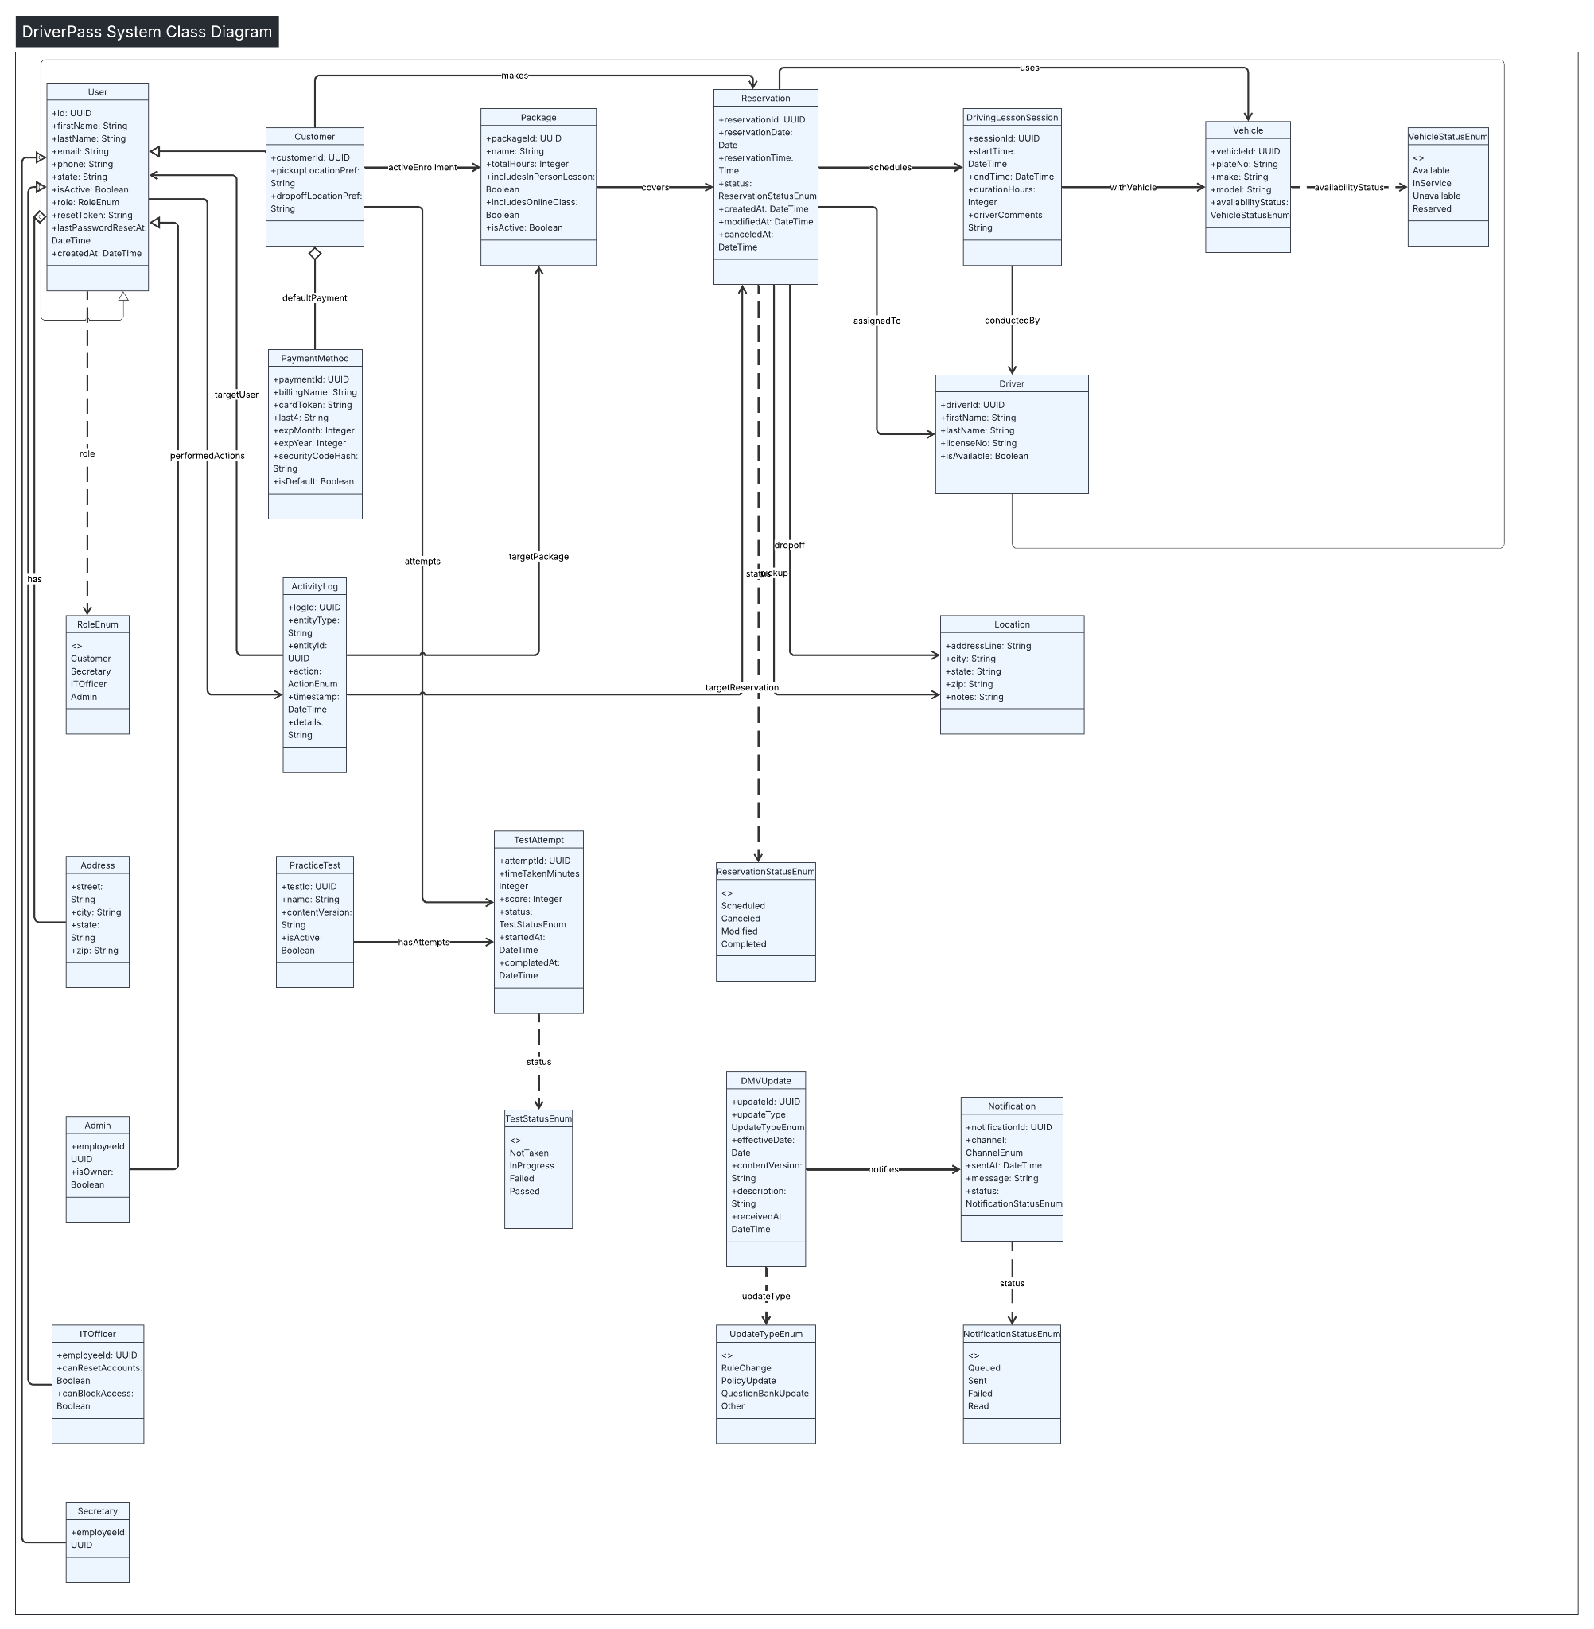

Technical Requirements
[Based on the diagrams you have created, describe the technical requirements of your system. These requirements should address the required hardware, software, tools, and infrastructure necessary for your system design.]

Users, Roles, and Access — Students/Customers, Secretary, Drivers, IT Admin, and Owner, each with the access they need
Core Functional Components — Scheduling 2‑hour lessons, enabling/disabling packages, practice tests with score & status tracking, driver notes, special needs & photos, reporting with Excel exports, “Contact Us” and student messaging, and payments via a compliant gateway
External Integrations — DMV updates with notifications, payment gateway, and email/SMS
Application Architecture & Software Stack — Cloud‑hosted, 3‑tier web app; responsive UI; RESTful API; relational database; secure file/object storage for photos and exports.
Hardware & Cloud Infrastructure — Browser‑based access from anywhere; managed cloud hosting, backups & autoscaling to reduce ops burden as requested
Security, Privacy, and Compliance —Access based roles, encryption, audit logs to track who created/modified/cancelled reservations, password resets, and PCI‑aligned payment handling
Non‑Functional Requirements — Availability, performance targets, scalability, usability, maintainability, and observability.
Data Model Highlights — Users/Roles, Vehicles & Drivers, Packages (with enable/disable), Reservations (2‑hour sessions), Test Attempts (name, time, score, status), Notes, Photos, Special Needs, Payments, and immutable Activity/Audit Logs
Environments, DevOps, and Tooling — Dev/Test/Prod separation, CI/CD, automated testing, and monitoring.
Assumptions & Constraints — Browser‑only MVP (no native apps), package enable/disable without code, DMV update feed, payment handled by gateway without storing, resources and budget

